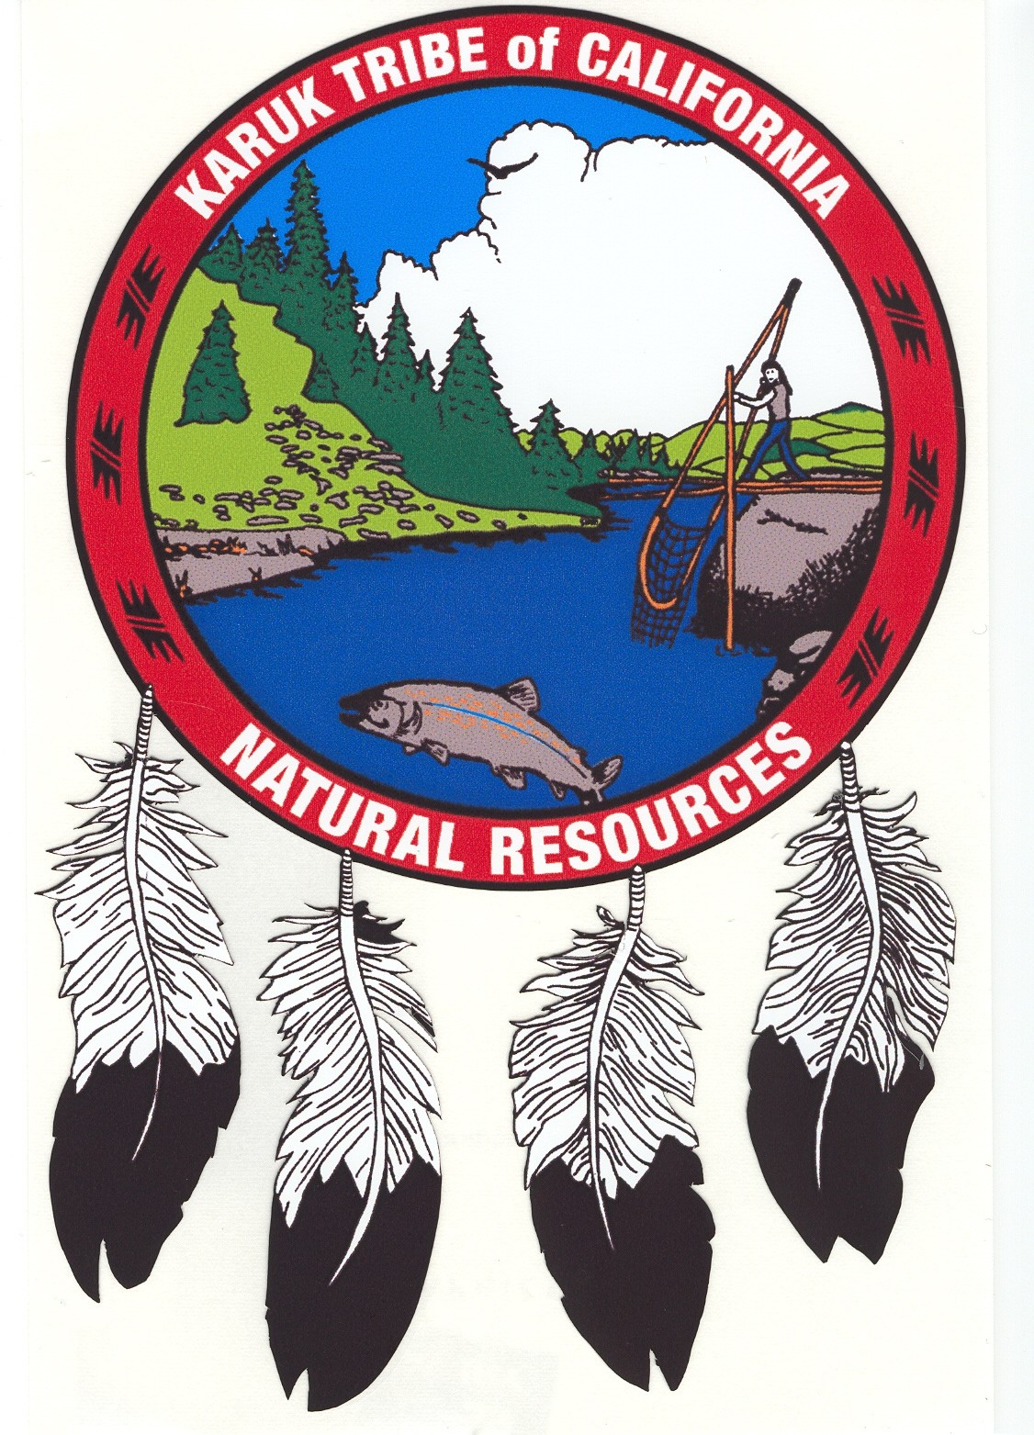


FOR IMMEDIATE RELEASE

Contacts:
David Fidanque, Executive Director, ACLU of Oregon, (541) 954-7731
S. Craig Tucker, Klamath Campaign Coordinator, Karuk Tribe of California
(530) 627-3446 Ext. 3027 (office) or (916) 207-8294 (cell)
Kelly Catlett, Hydropower Reform Policy Advocate, Friends of the River
(916) 442-3155 Ext. 223

Judge Rules Against TriMet in Free Speech Case

JUNE 3, 2008 – Judge Henry C. Breithaupt ruled Monday that TriMet’s refusal of a “political” advertisement was unconstitutional, on both state and federal grounds. The ACLU of Oregon’s victory on behalf on the Karuk Tribe of California and the Friends of the River Foundation makes clear that TriMet cannot violate free speech protections as it picks and chooses what ads to accept or deny.

Judge Breithaupt ruled that TriMet does not have to make its buses available for advertisements, but that if it does “it places itself in the same position as a government … (and) may not … violate the Oregon Constitution.” TriMet’s decision to deny an ad, the judge ruled, may not be based on the content of that ad.

“This is an important victory for free speech in Oregon,” said David Fidanque, Executive Director of the ACLU of Oregon. “No public transit system should be able to put itself above the state or federal constitution.”

The Karuk Tribe and Friends of the River had sought to place an ad on TriMet buses regarding the damage done to salmon runs by electricity-generating dams, owned by Portland-based Pacific Power, on the Klamath River. The ad depicts three salmon facing a wall of electrical sockets, along with the caption, “Salmon shouldn’t run up your electric bill. They should run up the Klamath River.” The ad then directs the public to a website – www.salmonforsavings.com – for more information. (A copy of the ad is attached.)

TriMet’s Advertising Standards Committee rejected the proposed ad on the grounds that it did not constitute an “advertisement” and that the public transit agency did not want its buses or property “to become a public forum for the dissemination, debate, and/or discussion of public issues.” The ACLU appealed the committee’s decision to TriMet’s general manager, who in a letter dated Jan. 18, 2008, upheld the rejection.

The ACLU argued that both rejections represent an unlawful restriction on speech in violation of Article 1, section 8, of the Oregon Constitution and the First Amendment of the U.S. Constitution. The judge agreed with the ACLU on both counts. TriMet may appeal the decision to the Oregon Court of Appeals.

The Karuk Tribe and Friends of the River seek to restore healthy salmon populations to the Klamath River. Their objective is the removal of PacifiCorp’s lower four Klamath River dams, allowing salmon to access more than 300 miles of their historic habitat.

The Karuk Tribe and Friends of the River cite economic studies by the Federal Energy Regulatory Commission and the California Energy Commission that show removing the dams and purchasing renewable replacement energy would save Pacific Power ratepayers about $100 million.

“We are pleased that the judge upheld the rights of Pacific Power’s customers to hear that dam removal can save them a significant amount of money,” said Kelly Catlett, Hydropower Reform Policy Advocate for Friends of the River.

Thomas M. Christ of Cosgrave Vergeer Kester LLP is the ACLU’s cooperating attorney on this case.

