The Karuk People’s Center
Presents
Spring 2011 Karuk Basketweavers Gathering
April 29th – May 1st
Friday 5 p.m. / Saturday all day / Sunday breakfast
The Karuk Tribe invites you and your family to share our
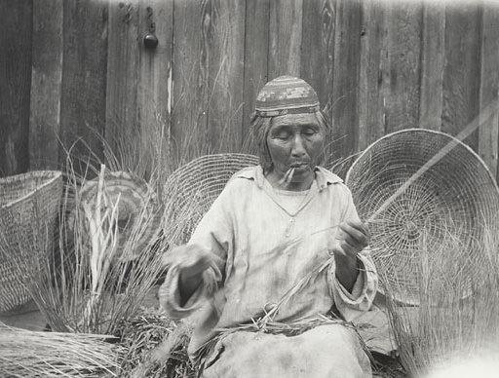
proud heritage of basket making
Mrs. Nellie Ruben, Karuk Basketweaver, 1930
Photograph courtesy University of California Special Collections
BRING YOUR PRIZE DONATIONS FOR BINGO!
Karuk Tribal Complex, Happy Camp, CA
For more information contact Hélène Rouvier at
530-493-1600 #2202
For registration forms online go to http://www.karuk.us

