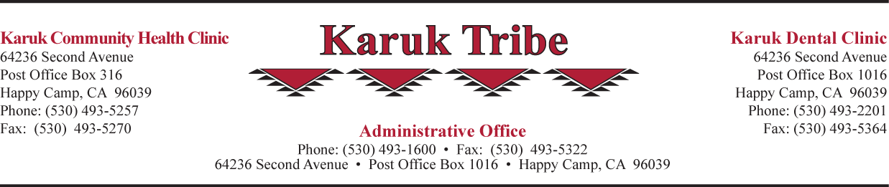

Vacancy Announcement

Title: Medical Assistant
(Tuesday-Friday 9:30 am–6:30 pm & Saturday 8:00 am –5:00 pm)

Reports To: Clinic Manager

Location: Yreka Clinic

Salary: $14.00 to $17.00 per hour, depending on experience

Classification: Full Time, Regular, Non-Exempt

Summary: The Medical Assistant shall work under the supervision of the Clinic Manager to provide medical and nursing support services. These include but are not limited to phlebotomy, injections, and brief assessments such as vital signs, height and weight and reasons for visit. Shall under supervision perform CLIA waived laboratory test. Shall document in accordance with the established PCC policy. Shall work as a team member and comply with AAAHC standards. Shall have knowledge of and understand clinic policy and procedures. Shall provide support to the Medical Records and Front Office as necessary.

Application Deadline: Open Until Filled

Applications are available at all Tribal Offices or on the Internet at www.karuk.us .The Karuk Tribe’s (TERO) Preference and Drug & Alcohol Policy apply.

If selected, applicants must successfully pass a drug screening test and be willing to submit to a criminal background check.

Job descriptions are available online at: www.karuk.us or by contacting the Human Resources
Department, Telephone (530) 493-1600 ext. 2041, Fax: (855) 437-7888, Email: vsimmons@karuk.us

POSITION DESCRIPTION

Title: Medical Assistant
(Tuesday-Friday 9:30 am–6:30 pm & Saturday 8:00 am –5:00 pm)

Reports To: Clinic Manager Location: Yreka Clinic
Salary: $14.00 to $17.00 per hours, Depending on Experience

Summary: The Medical Assistant shall work under the supervision of the RN/Business Office Manager to provide medical and nursing support services. These include but are not limited to phlebotomy, injections, and brief assessments such as vital signs, height and weight and reasons for visit. Shall under supervision perform CLIA waived laboratory test. Shall document in accordance with the established PCC policy. Shall work as a team member and comply with AAAHC standards. Shall have knowledge of and understand clinic policy and procedures. Shall provide support to the Medical Records and Front Office as necessary.

Responsibilities:
1. Shall provide medical and nursing support services, which include phlebotomy, injections, brief assessments
such as vital signs, height and weight and reason for visit.

2. Shall document using approved PCC policy.

3. Shall under supervision perform CLIA waived laboratory test.

4. Shall provide assistance to the clinic nurse with special patient educational programs.

5. Shall work as a team member and comply with AAAHC standards.

6. Shall assist in clinic management, which includes keeping patient areas clean and safe, cleaning equipment and maintaining supplies and the taking of inventories as directed.

7. Shall assist the Clinic Physician and the Family Nurse Practitioner as necessary.

8. Shall be cross trained to provide assistance to the Medical Records Department as necessary.

9. Shall be cross trained to provide support to the Front Office as necessary.

10. Routine duties shall include providing medical services, and other health care-related services in homes,
schools, clinics, job sites, and other community locations within the Karuk Tribe’s Service Area.

11. Shall be available for local and out of the area travel as required for job related training. Shall attend all required meetings and functions as requested.
12. Other job related duties as assigned.

Qualifications:
1. Have the ability to work effectively with Native American people in culturally diverse environments.

2. Have the ability to manage time well and work under stressful conditions with an even temperament.

3. Have the ability to establish and maintain harmonious working relationships with other employees and the public.

4. Have the ability to understand and follow oral and written instructions.
Requirements:
1. Must have a high school diploma or equivalency.

2. Must have verification of Medical Assistant proficiency and training. Two years experience as Medical Assistant or CNA, certification in Phlebotomy, and State of California certification in HIV Pre/Post Test Counseling are preferred.

3. Must become certified and remain current in infant, child and adult CPR.

4. Must possess valid driver’s license, good driving record, and proof of insurance and reliable transportation.
Must be insurable by the Tribe’s insurance carrier.

5. Must adhere to confidentiality and HIPAA policies.

6. Must provide documentation of immunity to measles and rubella or become vaccinated with the recommended vaccine and Hepatitis B vaccine and test annually for TB.

7. Must successfully pass a pre-employment drug screening test and be willing to submit to a criminal background check.

Tribal Preference Policy: In accordance with the TERO Ordinance 93-0-01, Tribal Preference will be observed in hiring.

Council Approved: March 13, 2003/Revised March 24, 2005

Chairman’s Signature:

Employee’s Signature:

