

General Election
November 5, 2013

UNOFFICIAL List of Candidates

The following candidates have met all requirements to compete for the Orleans District Member at Large position in the upcoming General Election, pending successful completion of their background checks.

Orleans District
Member-at-Large, Four (4) Year Term, 2013-2017

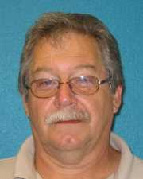  Harold Tripp | 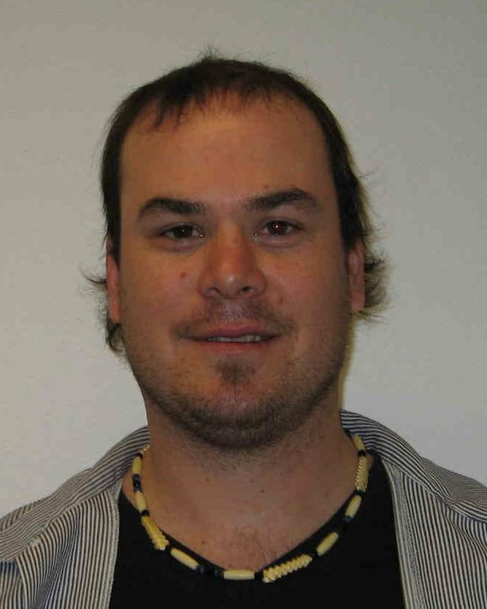  Joshua Saxon-Whitecrane | 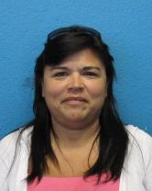  Dora Bernal

