Karuk Tribe Job Vacancy Posting Request

Position to be posted: | KTHA, Temporary Full Time Custodian Yreka
Circle One:
Regular Posting  (10 calendar days) |  |  | Emergency Posting (4 business days)  (Attach Justification in writing)
Open until Filled  (Attach Justification in writing) |  |  | Other Instructions  (Attach Instruction/Justification in writing):
Post Announcement from (Posting Date): |  |  | January 24, 2018
To (Desired Closing Date): |  |  | February 5, 2018
List where you want this vacancy advertised:
As much local coverage as possible: Tribal Offices, Local EDD / Workforce Connection Office, Yreka NCIDC, Tribal Website, Karuk User Email, Karuk Facebook Page.

List at least two possible interview dates/times: (Based on Staff Availability):
TBD.

✗ Attach/Email Most Current Council Approved for Job Posting & Job Description (Attached).

✗ Attach/Email Specific Interview Questions for this position (Attached).

Authorized by (Supervisor): |  | 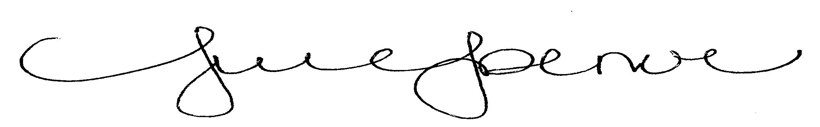 |  | 1/24/18
Signature |  |  |  | Date
Authorized by HR Director:
Signature |  |  |  | Date

