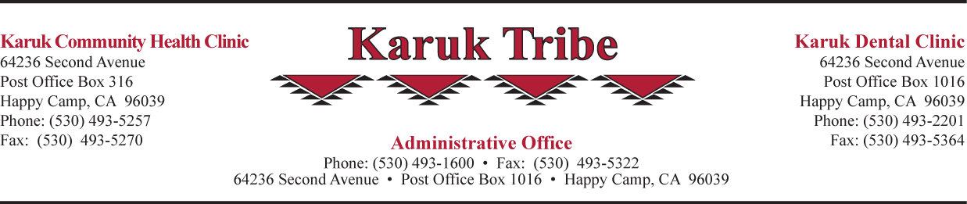
RESOLUTION OF THE
KARUK TRIBE

Resolution No: 21-R-XXX
Date Approved: [Date Approved]

RESOLUTION AUTHORIZING [INSERT WHAT THE RESOLUTION’S PURPOSE IS OR WHAT IT IS AUTHORIZING HERE]

WHEREAS; the Karuk Tribe is a Sovereign Aboriginal People, that have lived on their own land since long before the European influx of white men came to this continent; and

WHEREAS; the members of the Karuk Tribe have approved Article VI of the Constitution delegating to the Tribal Council the authority and responsibility to exercise by resolution or enactment of Tribal laws all the inherent sovereign powers vested in the Tribe as a Sovereign Aboriginal People, including negotiating and contracting with federal, state, Tribal and local governments, private agencies and consultants; and

WHEREAS; the members of the Karuk Tribe have approved Article VIII of the Constitution assigning duties to the Chair, Vice Chair, and Secretary/Treasurer including signing and executing all contracts and official documents pertaining to the Karuk Tribe; and

WHEREAS; the Karuk Tribe is a federally recognized Tribe and its Tribal Council is eligible to and is designated as an organization authorized to Contract pursuant to P.L. 93-638, as amended, on behalf of the Karuk Tribe; and

WHEREAS; the Karuk Tribal Council endorsed the United Nations’ Declaration on the Rights of Indigenous People on January 26, 2012; and

WHEREAS; [Include as many WHEREAS clauses as necessary to convey the history, background, recognized facts, or compelling reasons that lead up to a concrete action]; now

THEREFORE BE IT RESOLVED; that [Include as many THEREFORE BE IT RESOLVED clauses necessary to clearly explain the action you would like Karuk Tribal Council to take to protect tribal sovereignty, governmental status, self-determination, health and welfare, etc. If there will be more than one THEREFORE BE IT RESOLVED, follow with an “and” and on the last THEREFORE BE IT RESOLVED use “now”]; now

THEREFORE BE IT FINALLY RESOLVED; that the Karuk Tribal Council [restate the purpose of the resolution or what the resolution is authorizing from the header here].

CERTIFICATION
I, as Chairman, hereby certify the foregoing resolution [Resolution Number] which was approved at a [Health Board Meeting, Regularly Scheduled Tribal Council Meeting, Special Meeting, or Phone Vote] on [Date], was duly adopted by a vote of _____ AYES, _____ NOES, _____ ABSTAIN, and said resolution has not been rescinded or amended in any way. The Tribal Council is comprised of 9 members of which _____ voted.

___________________________________ ___________________________
Russell Attebery, Chairman Date

