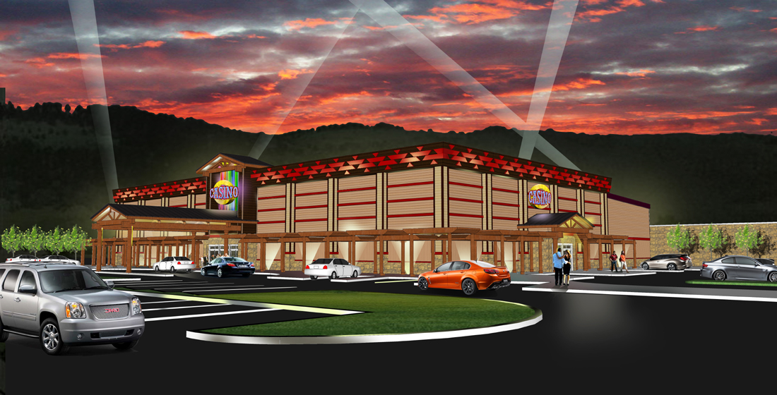
KARUK CASINO

Karuk Araras, ayukîi huut kich
The Tribal Council would like to update you on the Tribe’s gaming and hotel venture in Yreka California. A major milestone was accomplished in December 2013 when Governor Jerry Brown signed the Karuk Gaming Compact with the State of California.
On February 7, 2014 Karuk Tribal Council adopted and certified a Final Tribal Environmental Impact Report (TEIR) for both Phase 1 and Phase 2 of the project. The TEIR has identified potential environmental impacts from the construction and operation of our project. Mitigation measures have been identified to address those potential impacts. Tribal Staff and Council Members have been meeting with the City of Yreka staff and Council members and with the Siskiyou County Board of Supervisors to negotiate the mitigation measures identified in the TEIR, as well as addressing other concerns.

On March 4th, 2014 the Siskiyou County Board of Supervisors held a meeting to get public feedback on the Casino Project. At this meeting the public raised concerns regarding; the parcel of land on which the gaming project will be constructed, environmental and aesthetic impacts to the community including pollution to Yreka Creek, impacts to the city water and wastewater infrastructure, and concerns over the Karuk Tribe’s hiring practices for casino and hotel jobs. The TEIR addresses all of these concerns.
A main concern appears to be that the casino will bring more crime and poverty to the local area. Studies have shown that there is not a significant increase in crime from casinos. We will have the finest security and surveillance systems at the casino. The local median income in gaming communities vs. non-gaming communities is significantly higher. Additionally the revenue from the casino will allow the Karuk Tribe to be more self-sufficient. Funds from the casino will assist with Tribal Programs.
The next step for a successful gaming project is the Karuk Tribe’s gaming compact must be approved by the State Legislature before it becomes law and can be implemented. We are asking for your help and support in this Tribal Gaming Compact Approval Process. Please contact or write our local district representatives for the California State Legislature to express your support of the Karuk Tribe’s gaming venture. A draft letter can be found on the Karuk Tribe website www.karuk.us.

Karuk Tribal Council
CONTACTS

Office of Assemblyman Brian Dahle
1st District
280 Hemsted Drive, Suite 110
Redding, CA 96001
Phone: (530) 223-6300
http://arc.asm.ca.gov/member/AD1/

Office of Senator Ted Gaines
1st District
1670 Market Street, Suite 244
Redding, CA 96001
Phone: (530) 225-3142
http://district1.cssrc.us

